4 SQ MTR SOLAR PARABOLIC COOKER
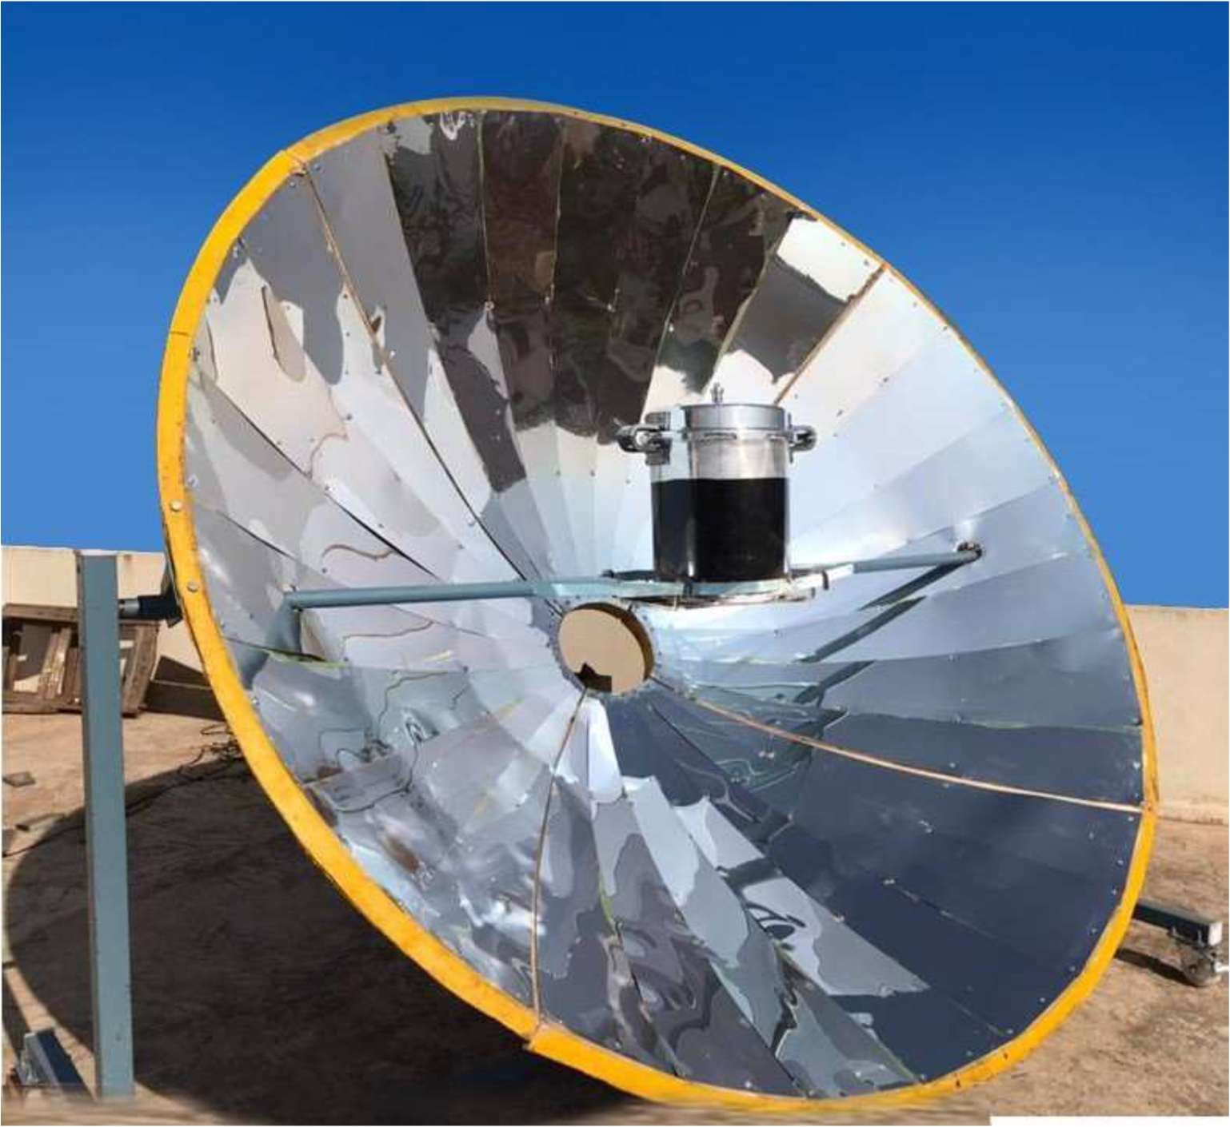
Technical Specification
 | For 25-30 person
1 | Type of concentrator | Point focusing
2 | Aperture Area | 4.83Sq mtr ( Diameter :2.48)
3 | Reflector | Anodized aluminium reflector
4 | Thickness | 0.4mm
5 | Size of focal spot | 0.40 Sq mtr
6 | Shape of focal spot | Circular
7 | Focal Length | 0.58m
8 | Tracking Device | Manually
9 | Construction of materials | MS
10 | Reflectivity of mirror | more than 80%
11 | Type of vessel used materials | Pressure cooker 20Ltr Aluminium
Financial offer: (Ex works)

SL NO | Descriptions | Qty | Amount per Unit
01 | Supply of 4 Sq mtr Solar Parabolic cooker | 1 | 125,000/-
GST 18% |  |  | 22,500
Packing 3% |  |  | Extra
Freight and Insurance |  |  | To your account
Installation and commissioning |  |  | Extra

Feasibility or Payback details:
Pratima Enterprises (DF) LPG consumption and payback period
No of month | No of LPG/month | Kg of LPG | Amount | Total Amount
1 | 10 | 192 | 1800 | 18000
10 | 100 | 1920 | 18000 | 180000
20 | 200 | 3840 | 36000 | 360000
28 | 280 | 5376 | 50400 | 504000

Based on above details the payback period of Solar Parabolic cooker is less than 1 year (10 Months).

